Design and Development of LiKerBOT

**MINOR PROJECT REPORT**

Submitted in partial fulfillment of the requirements

For the degree of

**BACHELOR OF ENGINEERING**

In

**COMPUTER SCIENCE & ENGINEERING**

By

**GROUP NO. 41**

SHYAM MAURYA (0187CS171153)

NAVNEET PUROHIT (0187CS171089)

Under the guidance of

**Dr. Rajeev Kumar Gupta**

Associate Professor Department of CSE/IT

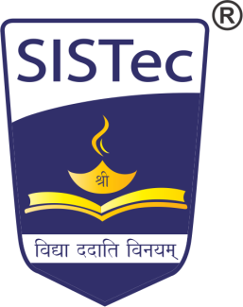

**Oct-2019**

**Department of COMPUTER SCIENCE & ENGINEERING**

**Sagar Institute of Science & Technology (SISTec)**

**Bhopal (M.P.)**

**An ISO 9001:2008 Certified Institution**

**Approved by AICTE, New Delhi & Govt. of M.P.**

**Affiliated to Rajiv Gandhi Proudyogiki Vishwavidyalaya, Bhopal (M.P.)**